Worth The Words
Binary Bunch
Project Management Plan

Version: 2.0.0 Date: (04/27/2025)

Document History and Distribution

- Revision History

Revision # | Revision Date | Description of Change | Author
1.0 | 01/27/2025 | Initial Document | Binary Bunch
1.1 | 02/03/2025 | Drafted | Binary Bunch
1.2 | 02/24/2025 | Updating RTM and SOW | Binary Bunch
1.3 | 03/08/2025 | Updating Format of PMP and Items | Binary Bunch
2.0 | 4/27/2025 | Finalized PMP | Binary Bunch

Table of Contents

Table of Contents
1. Executive Summary 2
2. Project Schedule 3
3. Statement of Work: 4
4. Project charter: 6
5. Requirements Management Plan 9
6. Requirements Traceability Matrix 13
7. Management Plan 13
7.1.1 Escalation Procedures 13
8. Project Budget - Total Cost of Ownership 14
9. WBS / WBS Dictionary 14
1.0 Project Research 14
2.0 Planning 15
3.0 Technical Framework 15
4.0 Establish Design 15
5.0 Site Development 15
6.0 Testing 16
7.0 Launch the Site 16
10. Diagrams (ERD, UFD, SAD) 17
11. References 18
12. Appendices 18

Executive Summary

Worth the Words Inc has approached our team with the task of redesigning their website to maximize its online engagement, improve user experience, minimize maintenance needs, and better align with their mission of preventing youth violence in Louisville through music programs. The end of this project will deliver a completely redesigned interface with enhanced functionality for event and volunteer registration, contact messaging, newsletter subscription, and more. The project will start on January 14, 2025 and will close on April 27, 2025. Once this project has been completed, the ownership will be transferred to the administrative leadership team at Worth the Words Inc.

Project Schedule

Deliverables | Assigned to | Date
User Flow Diagram | Nick Frondorf | 2/3/2025
Systems Architecture Diagram | Alex Welsh | 2/3/2025
Entity Relationship Diagram | Cora Alward | 2/3/2025
Project Charter | Becca Gossett | 2/3/2025
Statement of Work | Alex Welsh | 2/5/2025
Project Status Report 1 | Binary Bunch (Team) | 2/10/2025
Event Calendar V1 | Becca Gossett | 3/3/2025
Community Partners V1 | Becca Gossett | 3/3/2025
Donation Module V1 | Ben Leonard | 3/3/2025
Volunteer Sign-up V1 | Nick Frondorf | 3/3/2025
Contact Form V1 | Cora Alward | 3/3/2025
Landing Page / Project Showcase V1 | Alex Welsh | 3/3/2025
Summary of Dev Progress | Binary Bunch (Team) | 3/3/2025
Event Calendar V2 | Becca Gossett | 4/1/2025
Community Partners V2 | Alex Welsh | 4/1/2025
Donation Module V2 | Ben Leonard | 4/1/2025
Volunteer Sign-up V2 | Nick Frondorf | 4/1/2025
Contact Form V2 | Cora Alward | 4/1/2025
Landing Page / Project Showcase V2 | Alex Welsh | 4/1/2025
Project Status Report 2 | Binary Bunch (Team) | 4/6/2025
Requirement Traceability Matrix - Latest Version | Binary Bunch (Team) | 4/6/2025
Final Event Calendar | Becca Gossett | 4/22/2025
Final Donation Module | Ben Leonard | 4/22/2025
Final Volunteer Sign-up | Nick Frondorf | 4/22/2025
Final Contact Form | Cora Alward | 4/22/2025
Final Project Showcase | Alex Welsh | 4/22/2025
Final Homepage | Becca Gossett & Alex Welsh | 4/22/2025
Final Shop Page | Ben Leonard | 4/22/2025
Final About Us | Various Members | 4/22/2025
Final Footer | Becca Gossett & Alex Welsh | 4/22/2025
Final Mobile View | Alex Welsh | 4/22/2025
Final Project Status Report | Binary Bunch (Team) | 4/27/2025
Final Requirement Traceability Matrix | Binary Bunch (Team) | 4/27/2025
Final Project Management Plan | Binary Bunch (Team) | 4/27/2025

Statement of Work:

PROJECT TITLE | Worth the Words Infrastructure
TEAM NAME | Binary Bunch |  | CLIENT |  | Demarco Harris
PROJECT MANAGER | Prof Chrisman |  | DATE SUBMITTED |  | 2/2/25
PROJECT BEGIN DATE | 1/14/25 |  | VERSION |  | 1.5.1
END DATE |  | 4/27/2025

3.1.0 INTRODUCTION

3.1.1 Background

Worth the Words is a non-profit organization that focuses on preventing youth violence in Louisville through music. The website is not currently meeting the needs of the sponsor, needing to be updated to improve the user experience, increase engagement, and bring more donations to the non-profit.

3.1.2 Quality Standards

The new site must:
- be easy to use and understand for the average person.
- have an up-time of 99% giving it 88 hours per year.
- store all collected data securely and responsibly.
- comply with the IRS 501(C)(3) Non-profit requirements.
3.2.0 Milestones

MILESTONE | RATIONALE
Sponsor review of SOW | Getting the preparation for the project cleared.
Demo 1 | The site is at least 50% finished
Demo 2 | The site is at least 75% finished
Final Demo | The site is 100% finished
Last day of course | All documentation is complete and whole

3.3.0 SCHEDULE

TASK # | DUE DATE | DELIVERABLE DESCRIPTION
3.1 | 1/27/25 | Complete and submit RTM
3.2 | 1/27/25 | Complete and submit RMP
3.3 | 1/04/25 | Email SOW for Sponsor review
3.4 | 3/04/25 | Present Demo 1
3.5 | 4/01/25 | Demo 2 presentation
3.6 | 4/15/25 | Complete and submit the latest version of RTM
3.7 | 4/22/25 | Final Power PowerPoint and demo
3.8 | 4/22/25 | Final RTM

3.4.0 Technology / Infrastructure

The site will be built on Wix using the business. All security, analytics, and features will be through Wix. The donation module will reroute users to PayPal, which the organization has been using prior to redesigning. The Facebook view will be embedded from Sociable Kit.

3.5.0 PROJECT RISKS

PROJECT RISKS
ISSUE / RISK | MITIGATION / CONTINGENCY
Data Security | Only sharing data with trusted sources. Outsourcing security risks such as payments.
Site administration | Can be done by the owner of the site or have a worker/volunteer manage it.
Monetary loss | The site will work as a funnel to both increase traffic to events and increase donations.

3.6.0 CHANGE MANAGMENT PLAN

Approved change requests from sponsors will be documented in the requirement traceability matrix and project management plan. Requests will be approved based on feasibility, scope, and budget.

3.7.0 CONSTRAINTS

- IRS 501(C)(3) Non-profit requirements
- Limited Budget
- Limited maintenance resources

3.8.0 AUTHORIZATION
AUTHORIZATION
CLIENT | ROLE | Worth the Words Founder
CLIENT | NAME | Demarco Harris
CLIENT | DATE | 4/22/2025
PROVIDER | NAME | Binary Bunch
PROVIDER | DATE | 4/22/2025

Project charter:

GENERAL PROJECT INFORMATION
PROJECT NAME | Worth the Words Website Redesign
PROJECT SPONSOR | Demarco Harris
TEAM NAME | Binary Bunch
VERSION | 1.5.1
EXECUTIVE SUMMARY, GOALS, OBJECTIVES, AND DELIVERABLES OF THIS PROJECT
EXECUTIVE SUMMARY | This document outlines the goals and frameworks for redesigning the Worth the Words website. Our project charter sets out our milestones, while also addressing the potential risks and constraints. Our goal is to improve the user experience, increase engagement, and enhance current features while continuing to align or efforts with the mission of the organization. We aim to revamp the key features of the current site such as donations, social media integration, and volunteer registration.
GOALS / OBJECTIVES | - Update the website design to better align with the organization’s mission and target audience  - Allow users to have seamless and sensible site navigation  - Ensure the backend of site has access to all needed analytics and maintenance features (form editor, replying to user questions, etc)
EXPECTED DELIVERABLES | - Event calendar  - Display upcoming events  - Allow users to RSVP from the calendar view  - Send event reminders to users via email  - Interactive calendar events to lead to more information  - Notify admin of event RSVP via email  - Donations  - Allow users to manage donation history view  - Visible button on all pages  - Allow for recurring or one-time payments  - Allow payment confirmation messages  - Volunteer Sign-Up  - Facilitate registration process  - Automatic confirmation  - Display information on volunteer opportunities  - Display all available volunteer events  - Contact Form  - Provide a simple question outlet  - Increase community engagement  - Allow sponsors to parents to reach out  - Allow option for submission to be viewed via email  - Project Showcase  - Highlight current projects  - Highlight completed projects  - Increase transparency  - Increase community engagement  - Social Media Integration  - Integrate social media links  - Integrate social media feeds  - Improve engagement  - Improve visibility  - Mobile Optimization  - Responsive design for mobile users  - Maintain useability without sacrificing functionality  - Shop  - List of available merchandise products  - Allow page to be hidden from user view  - Seamless checkout process for customers
DEFINE THE PROJECT SCOPE AND STATEMENT OF WORK
WITHIN SCOPE | - New features requested by sponsor  - Redesigning the interface to align with goals
OUTSIDE OF SCOPE | - Any customization outside of our reach (third-party)  - Long-term updates or maintenance (from our team)  - Non-technical aspects such as volunteer policy
DEFINE THE SUCCESS CRITERIA AND APPROACH
SUCCESS CRITERIA | - Feedback from peers and sponsor  - Improved user experience  - Increased web traffic / engagement  - Increased in donations  - Project finished on time
APPROACH | - Previously researched and planned for the redesign (CIS 320)  - Divide site deliverables among team members  - Improve site features based on peer feedback and sponsor requests
MILESTONES | DELIVERABLE
DEMO 1 (3/04) | 50% Dev complete
DEMO 2 (4/01) | 75% Dev complete
FINAL DEMO (4/22) | 100% Dev complete
COMPLETE DOCUMENTATION (4/27) | Fully finished PMP and RTM – updated with all completed tasks and necessary information
DESCRIBE PROJECT RISKS, CONSTRAINTS, DEPENDENCIES, AND ASSUMPTIONS
RISKS | Scope creep, delays, lack of content (photos, descriptions)
CONSTRAINTS | Budget, time, experience, resources
DEPENDENCIES | Third-party platforms, up-to-date content information
ASSUMPTIONS | - Sponsor will approve / request updates to features in timely manner  - Admin will maintain the site after ownership transfer (e.g. updating calendar events)
Prepared by: | Becca Gossett, Alex Walsh, Cora Alward, Ben Leonard, Nick Frondorf

Requirements Management Plan

VERSION 2.0
02/03/2025
VERSION HISTORY
VERSION | APPROVED BY | REVISION DATE | DESCRIPTION OF CHANGE | AUTHOR
1.0 | Binary Bunch | 01/20/2025 | Draft | Binary Bunch
2.0 | Binary Bunch | 02/02/2025 | Final | Binary Bunch
3.0 | Binary Bunch | 04/23/2025 | Updated and finalized | Binary Bunch

1. EXECUTIVE SUMMARY
Our team has been tasked with creating a website for Worth the Words Non-Profit Organization. We must ensure the website is mobile friendly and that all necessary requirements provided to us be the client are met for this project.

Purpose: Improve the WTW website to better function for users and administrative teams while documenting each step.
Goals: Create a new and improved website for Worth the Words
Objectives: Make it mobile friendly, include social media, updatable event calendar, newsletter, simple volunteer/contact forms, shop page with seamless checkout, and seamless donation portal

2. OVERVIEW
Project Sponsors: James Chrisman & Demarco Harris
Team Members: Cora Alward, Becca Gossett, Alexander Welsh, Ben Leonard, Nick Frondorf
Stakeholders: Users, Demarco Harris, Sponsors, Worth the Words

2.1 PROJECT SCOPE
The project scope for the Worth the Words website redesign will improve user experience and navigation, increase site visitation, increase donations, and inform users of the organization’s goals and opportunities.

To do this, we will:
- Update layout/organization of site
- Research the best resources to use
- Utilize all needed capabilities of Wix

2.2 WORK BREAKDOWN STRUCTURE (WBS)
The team will use the organization’s standard WBS to assign all tasks. Once we delegate the tasks, we will track them on the requirements management plan dashboard. We will repeat this on a weekly basis and delegate the necessary tasks throughout the team to ensure all requirements are met for the client. (Please see the attached WBS in section 9)
The full completed WBS is detailed in Section 9 of this Project Management Plan

2.3 REQUIREMENTS APPROACH

REQUIREMENTS ACTIVITY | PROCESS/APPROACH | NOTES
Gathering | Group Planning/Management | The group will gather twice a week to discuss the needed requirements and assign work for each member
Analysis | Group Analysis Meeting | During our meetings, the group will share what we have completed and open it up to the rest of the group for potential improvements to best suit our project.
Definition | See appendix for criteria
Prioritization | Prioritization matrix, BABOK 3.0 guidelines | We will decide requirements by priority of most important to least important while still ensuring chronological integrity. Our team will use a prioritization matrix to best ensure this process is being followed.
Validation and Maintenance | Prototyping, testing based, requirements inspection | We will validate (test) each deliverable to ensure overall integrity multiple times between team members. One we all believe a certain deliverable to be perfected, we will move on to the next deliverable.

2.4 REQUIREMENTS TYPE

REQUIREMENTS | TYPE | NOTES
PMS | Business Requirements | Make a simple, streamlined donation module for users
Events and Sponsor | Stakeholder Requirements | Event and Sponsor Information will be readily available and can be seamlessly updated to portray accurate information
Mobile Accessibility | Technical Requirements | Mobile friendly, easily accessible
Final Product | Solution Requirements | We will test all necessary requirements to ensure they are in working order and within the scope of the project.

2.5 CHANGE MANAGEMENT PLAN
If there is a change requested or needed, we will decide if it is a reasonable change within scope. If it is meaningful and reasonable then the change will be made, if it does not fit the scope of the project, then it can be held for later. If it is neither in scope nor a requirement, it will be skipped all together.
When a change is approved, the sponsor will be updated about any budget or timeline changes - change requests cannot heavily affect the timeline due to strict schedule. These changes will be documented as needed

3. TRACEABILITY AND TRACKING METRICS
We will use a requirements traceability matrix to record each requirement’s testing status, validation, issues, and verification. We will track variations if necessary.

Our tracking metrics include the following:

- Priority level
- Functionality
- Testing status
- Issues
- Deviations
- Change requests
- Dates

Each system requirement has been given a unique identification (on the RTM) number to track its progress.

4. PRIORITIZATION METHODS
We will record and rank urgent requirements using a requirements prioritization matrix as a group. During our meetings we will decide the priority of each requirement and the most logical, chronological course of action for these requirements. If change is needed to a requirements priority, the group will discuss and update accordingly. (Please see the attached RTM in next section)

The team will determine each requirements priority based on the sponsors’ need for each, potential for user impact, and technical feasibility. The requirements will be sorted into three categories: high, medium, or low priority.

Requirements Traceability Matrix
Listed below is our final requirements traceability matrix for our project.

Management Plan

7.1 Communication Plan

The communication plan is focused on enforcing transparency and accountability within the team for the entirety of the project. Binary Bunch members will meet virtually via Microsoft Teams on Tuesdays at 5:00PM and, when needed, Thursdays or Sundays at 5:00PM. The weekly meetings will focus on upcoming deadlines, sponsor change requests, and peer feedback, as well as any opinions shared by the team. In the meetings, tasks will be delegated to each individual and they will be expected to have updates each week on their progress or any concerns.
The primary communication platform used by the team will be GroupMe, being used for frequent check-ins and updates among members. Any urgent concerns should be sent through the GroupMe chat for members to address quickly.
All documents and files will be stored in a shared OneDrive folder to allow direct access to each member. Each document just be named clearly, and all names must be consistent as to minimize any confusion.
This plan will be updated as needed.

7.1.1 Escalation Procedures
- Identify the issue
- Document the issue
- Determine the escalation triggers
- Notify supervisor (Prof. Chrisman)
- Determined escalation level
- Set a deadline for the solution
- Document outcome
- Review and improve

7.2 Stakeholder Management Plan
The project sponsor for this project is Worth the Words founder, Demarco Harris. In his role as project sponsor, he holds full authority over requests, approvals, and final decisions. His feedback will be needed at every milestone, especially following each presented demonstration. The necessary feedback includes design elements, functionalities, and any new requirements that may be requested. During the three scheduled demonstrations, the full state of the site will be presented to Mr. Harris in search of his approval before the team can advance to the next stage. The team will prioritize flexibility to accommodate any feedback provided or change requests, guaranteeing the site meets all expectations and aligns with the goals and mission of Worth the Words Inc.

7.3 Progress Reporting Template (Status Report)
Listed below is the final progress status report for our project.

Project Budget - Total Cost of Ownership

For this project, the total cost to run the website will all necessary tools included is $261 yearly. This total mainly comes from the cost of the content management system Wix. Wix uses a subscription-based service to manage the website, and to ensure that the website meets all necessary requirements the Wix business subscription is needed. This normally comes at a cost of $36/month, however if you purchase the subscription for the entire year this cost is halved, making the monthly subscription only $18/month. We have also factored in the cost of the domain through Wix, which comes at $45/year. “Worth the Words” currently has a domain purchased, so if the domain is kept the same and not purchased through Wix, then the yearly payment will only be $216/yearly. Other than the cost to run the website and domain, PayPal also will take a fee for any donations made through their system. Due to “Worth the Words” being a non-profit organization, these fees would be 1.99% + $0.49 per donation made. Other than PayPal's fees, all other transactions made through Wix do not take a fee.

WBS / WBS Dictionary

9.1 Work Breakdown Structure (WBS)

1.0 Project Research
1.1 Technical Needs
1.1.1 Sponsor Expectations
1.1.2 Identify Platform
1.2 Analyze Current Site
1.2.1 Review Content
1.3 Analyze CMS Choices
1.3.1 Research WordPress
1.3.2 Research WIX

2.0 Planning
2.1 Timeline
2.1.1 Create project schedule
2.1.2 Create Deadlines
2.2 Define Goals and Milestones
2.2.1Create goals from sponsor needs
2.3 Budget Plan
2.3.1 Create Budget
2.3.2 Decide on WIX plan budget
2.4 Assign project Roles
2.5 Risk Management plan
2.5.1 Identify risks
2.5.2 Create mitigation strategies

3.0 Technical Framework
3.1 Choose services used
3.1.1 choose form service
3.1.2 choose payment services
3.1.3 choose Calander service
3.2 Choose WIX plan and features
3.2.1 Choose Wix plan
3.2.2 Choose required apps, or plugins.
3.3 Decide on template or scratch

4.0 Establish Design
4.1 Customizing the template
4.1.1 Choose a template
4.1.2 Customize template
4.2 Updating visuals
4.2.1 Changing logos
4.2.2 Choose color scheme
4.3 Create UI elements
4.3.1 Creating consistent buttons
4.3.2 Creating Donation button
4.4 Mobile design
4.4.1 Ensure uniformity in mobile version

5.0 Site Development
5.1 Build pages
5.1.1 Regular webpages
5.1.2 Specialty pages, e-commerce, donation and forms
5.2 Create forms page
5.2.1 create contact form
5.2.2 create volunteer form
5.3 connect payment methods
5.3.1 connect Google pay
5.3.2 connect PayPal

6.0 Testing
6.1 Functional testing
6.1.1 test navigation
6.1.2 test Purchasing and donations
6.1.3 test Calander
6.1.4 test forms
6.2 Mobile testing
6.2.1 check for fit
6.2.2 test navigation
6.3 Performance
6.3.1 test site responsiveness

7.0 Launch the Site
7.1 Launch the finished site
7.1.1 Ensure the site is active

9.2 WBS Dictionary

Diagrams (ERD, UFD, SAD)
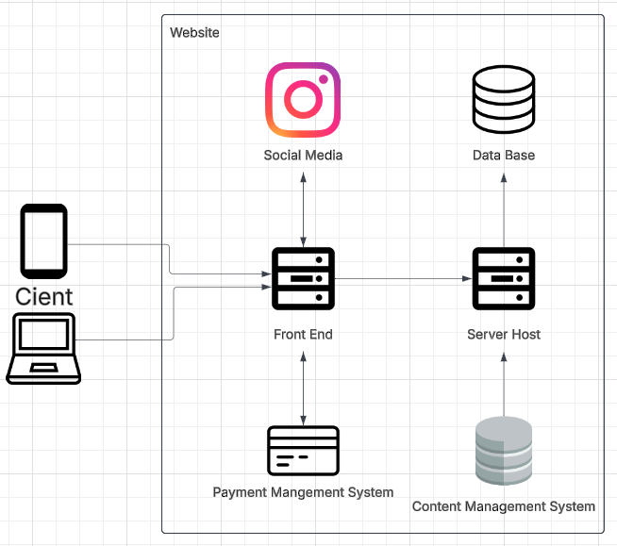

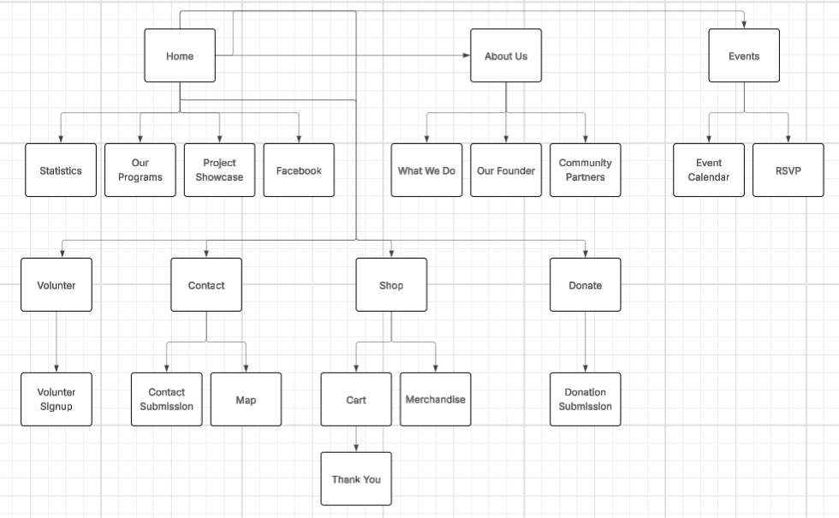

References
https://www.sociablekit.com/app/users/widgets/update_embed/25544485 (facebook embed)

https://support.wix.com/en/article/contacting-wix-customer-care-for-support

https://www.wix.com/plans

https://donorbox.org/nonprofit-blog/paypal-nonprofit-donation-fees

Appendices

12.1 Appendix A: Solution Transfer
If our website is chosen as the desired design for “Worth the Words”, we would first get with Demarco and have him create a Wix account. He will need this for any future design changes or updates he may need to make in the future. Once his account has been created, he will be added as the owner of the current website where he will have full access to the backend. We will remove the current domain and replace this with the current Worth the Words domain unless the purchase of a new Worth the Words domain is needed. From there we will walk Demarco through the Wix manager and assist with any questions he may have about managing Wix. Once he is comfortable with managing the website, we will all remove our accounts that are currently tied to the site, giving Demarco sole admin access. He will also walk Demarco through adding other users in the case he would like others to have admin access in the future.

12.2 Appendix B: Solution Technical Support
Once the website has completely been transferred over, we will keep in contact with Demarco for the next month to ensure that the website is working well. If any issues were to occur, we will try to troubleshoot and resolve the problem for Demarco. If there is issues with Wix itself that we cannot resolve, we will also provide the contact details for Wix support to Demarco. These contact details are the following: Wix Customer Support Chat- https://www.wix.com/contact?referral=article_0bdfcec6-a05e-4604-be55-cacd7e912259. This chat enables AI to help resolve issues within Wix, if there is still an issue that the chat bot cannot resolve, a ticket will be made with Wix’s support team, where they will contact Demarco directly via phone and or email to help resolve the issue he is having.

12.3 Appendix: C Solution Final Demo PDF
Embedded below is the final demo PowerPoint presentation for our “Worth the Words” website design. It contains all necessary requirements given to us by Demarco and all design changes have been completed to produce the following final version of the website.

