Iteration 5
CIS 320-02
Syntax Sorcerers
Cora Alward, Jackson Hallahan, Justin Puentes, Luke Johnson, Stefan Vuleta

1. Class Diagram
1.1 Class Diagram Narrative
Our class diagram is a visual representation of the system we designed for GuideBookCo. It includes the relationships, attributes, and operations for each class contained within the system. The bottom section of each entity contains the class’s operations, which were identified based on the use cases and their functionalities. While it may seem overwhelming at first, it is easiest to first inspect the User class. It is the parent class of its two subclasses, Client and Guide, meaning that they inherit its attributes. The unique attributes for the Client and Guide classes are listed in those tables. The User class is abstract and defines the behavior of its two concrete subclasses. These three classes only have relationships with other classes that they interact with and that are relevant to them.
Looking at the User class, we see only two relationships with other entities: Chat Widget and Website. Since both clients and guides will interact with the website and the chat widget, their parent class, User, has relationships with those two entities. The User uses the chat widget, and from there the classes branch out. The chat widget contains the group chats and stores the chat history. From the Chat History table, there is a relationship with Message. The Message table has the relationship “contains” with the File table. Each of these entities need their own table to keep tables from producing redundancy errors.
When comparing the Client and Guide classes, it quickly becomes apparent that the Client entity has many more relationships with other entities. Starting at the top-left, Client has a relationship with Client Survey Response, which is a bridge entity that connects Client to Survey. Survey also connects to the Question table which stores the questions for the survey and all other relevant information. Next, the Client and Cart tables share a relationship. When a client buys a subscription, buys merchandise, or books a trip, their items will be placed in their cart and stored in the Cart table. The Cart table does not directly connect with the Payment and Merchandise classes. Instead, the bridge entity Cart_Merchandise handles the many-to-many relationships the other entities could not handle by having relationships with Cart and Merchandise and then connecting to Payment. When the user makes a payment, it is processed by the payment facilitator and the information is stored in the respective tables. We thought it was appropriate to include the Payment Facilitator class because our system will be interacting with the payment facilitator. Although it was not essential to include it in our diagram, we did so for completeness.
Next, the client creates a support request stored in the Support Request table, which also happens to be a bridge entity linking the client to customer support. Above that, Client connects to Invite, which is the class representing the initial client onboarding and the link associated with it. If an administrator wishes to onboard a client manually, they will select the link generated and stored by the Invite entity. Continuing counterclockwise, Client has a relationship with Waitlist in that zero-to-many clients can join zero or one waitlists. The primary key waitlistID in Waitlist acts as a foreign key in Client and links the two tables.
When a user books a trip, the information is stored in the Booking entity and is linked to the Client table by putting the userID in Booking as a foreign key. This associates each booking with a unique userID. The opposite is true for the Subscription table. It also shares a relationship with Client, but its primary key acts at the foreign key within the User table. Referential Integrity is maintained, and the subscription information can be stored in its own class but referenced easily.
Unlike the Client class, the Guide class only has one exclusive relationship, and that is with the Trip class. Guides can build and modify trip pages, with all the trip information stored in the Trip table. Regarding the Administrator class, we thought it was best to keep it separate from the parent User class since there would be no need for inheritance for either entity. It is the parent class in every relationship with other entities except for the Website class.
Equally important to discussing the details contained within the class diagram, we must explain how the diagram was constructed. Our class diagram was derived using noun/verb analysis. We were first very careful to fully understand the problem domain and to define it. To do this, we collected as much information as possible about the domain from as many sources as we could find. When we collected all that we could from internal sources, we looked to other organizations for similar problem domains. As we progressed, we learned that there were “hidden” classes that were intrinsic to the problem domain but weren’t initially obvious to us. Examples of these classes are Question, File, Client Survey Response, Cart_Merchandise, Support, and Invite.
As mentioned earlier, the first step in noun/verb analysis is to collect all the relevant information that you can find. Two of our most influential sources of information were the use case and requirements model. Once the information has been collected, we analyzed it and highlighted the nouns, noun phrases, verbs, and verb phrases. This was the second step we took because it allowed us to look at the nouns and noun phrases and began to see what the classes and class attributes might be. Also, the verbs and verb phrases we highlighted indicated what the class responsibilities might be. Once we had a list of candidate classes, attributes, and responsibilities, we assigned the attributes and responsibilities to their respective classes. The responsibilities became the operations for each class. At the end of this process, we had a first draft class diagram that we refined over time.
1. 2 Class Diagram
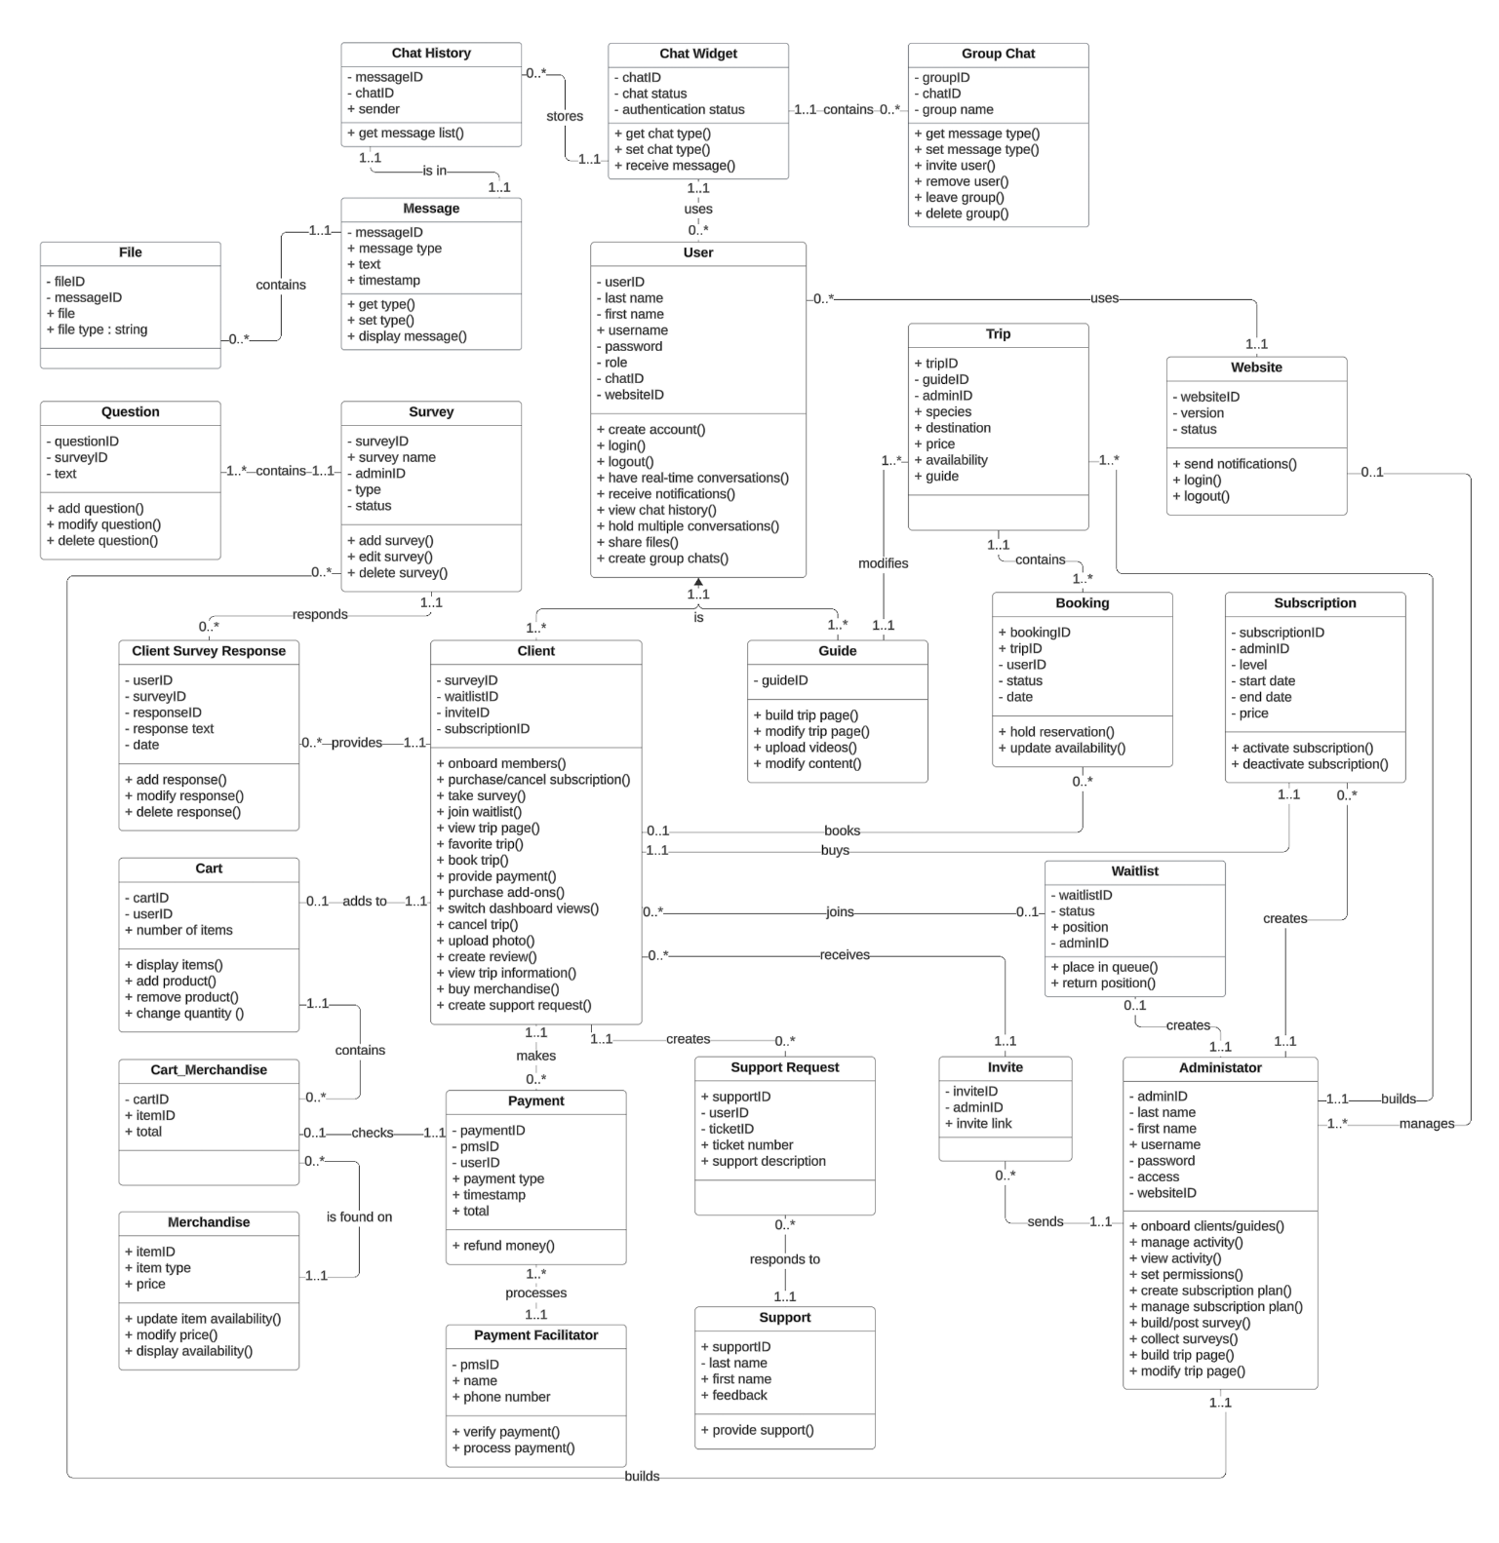

2. Database Design
2.1 Database Diagram Narrative

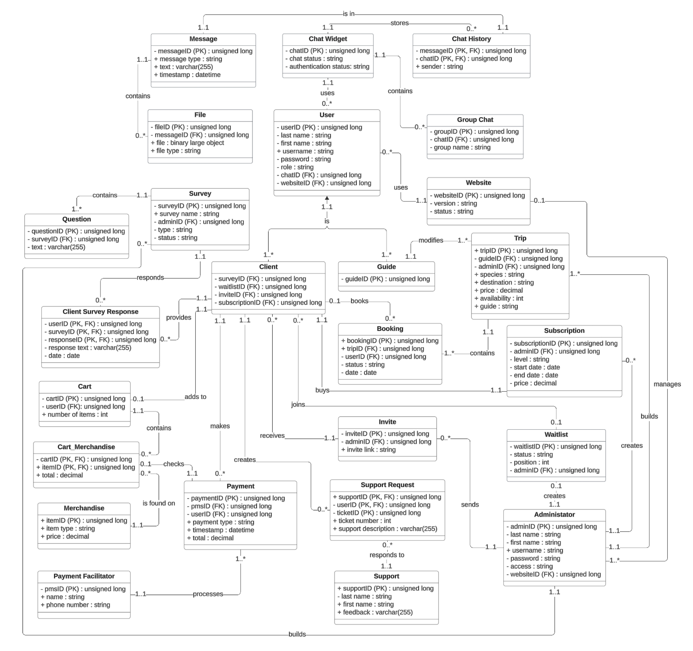

2.2 Database Narrative

2.3 Database Definitions
MESSAGE TABLE
Attribute | Definition | Type | Size | Key
messageID | Unique identifier for an individual message | Unsigned long | 4 Bytes | Primary
message type | The type of message: text, multimedia, or system | String | Number of Characters + 2 Bytes | No
text | The text contained within the message | Varchar(255) | 255 Bytes | No
timestamp | The time the message was received | Datetime | 8 Bytes | No

CHAT HISTORY TABLE
Attribute | Definition | Type | Size | Key
messageID | Unique identifier for an individual message | Unsigned long | 4 Bytes | Primary, Foreign
chatID | Unique identifier for each facilitated chat session | Unsigned long | 4 Bytes | Primary,  Foreign
sender | Who sent the message (username) | String | Number of Characters + 2 Bytes | No

CHAT WIDGET TABLE
Attribute | Definition | Type | Size | Key
chatID | Unique identifier for each facilitated chat session | Unsigned long | 4 Bytes | Primary
chat status | The status of the chat widget: online, offline, or idle | String | Number of Characters + 2 Bytes | No
authentication status | The current authentication status of the user: granted, denied, pending, or expired | String | Number of Characters + 2 Bytes | No

GROUP CHAT TABLE
Attribute | Definition | Type | Size | Key
groupID | Unique identifier for each group chat created or joined | Unsigned long | 4 Bytes | Primary
chatID | Unique identifier for each facilitated chat session | Unsigned long | 4 Bytes | Foreign
group name | The name of the group chat group | String | Number of Characters + 2 Bytes | No

USER TABLE
Attribute | Definition | Type | Size | Key
userID | Unique identifier for a user | Unsigned long | 4 Bytes | Primary
last name | Individual user’s last name | String | Number of Characters + 2 Bytes | No
first name | Individual user’s first name | String | Number of Characters + 2 Bytes | No
username | A user picked username, likely will have a character limit and must meet community guidelines. | String | Number of Characters + 2 Bytes | No
password | A user picked authentication credential with at least 8 characters, an upper-case letter, and a symbol | String | Number of Characters + 2 Bytes | No
role | The role the user takes (client/guide/  prospective client) | String | Number of Characters + 2 Bytes | No
chatID | Unique identifier for each facilitated chat session | Unsigned long | 4 Bytes | Foreign
websiteID | Unique identifier for the underlying system | Unsigned long | 4 Bytes | Foreign

QUESTION TABLE
Attribute | Definition | Type | Size | Key
questionID | Unique identifier for a question | Unsigned long | 4 Bytes | Primary
surveyID | Unique identifier for a survey | Unsigned long | 4 Bytes | Foreign
text | The question’s displayed text | Varchar(255) | 255 Bytes | No

SURVEY TABLE
Attribute | Definition | Type | Size | Key
surveyID | Unique identifier for a survey | Unsigned long | 4 Bytes | Primary
adminID | Unique identifier for an administrator | Unsigned long | 4 Bytes | Foreign
survey name | The name of the survey | String | Number of Characters + 2 Bytes | No
type | The survey’s type: research, feedback, and ad hoc | String | Number of Characters + 2 Bytes | No
status | The survey’s status: active or inactive | String | 4 Number of Characters + 2 Bytes | No

TRIP TABLE
Attribute | Definition | Type | Size | Key
tripID | Unique identifier for a trip | Unsigned long | 4 Bytes | Primary
guideID | Unique identifier for a guide | Unsigned long | 4 Bytes | Foreign
adminID | Unique identifier for an administrator | Unsigned long | 4 Bytes | Foreign
species | The species of fish targeted | String | Number of Characters + 2 Bytes | No
destination | The trip’s location | String | Number of Characters + 2 Bytes | No
price | The price of the trip | Decimal | 3 Bytes | No
availability | The trip’s availability | String | Number of Characters + 2 Bytes | No

CLIENT SURVEY RESPONSE
Attribute | Definition | Type | Size | Key
userID | Unique identifier for a user | Unsigned long | 4 Bytes | Primary, Foreign
surveyID | Unique identifier for a survey | Unsigned long | 4 Bytes | Primary, Foreign
responseID | Unique identifier for a user’s response | Unsigned long | 4 Bytes | Foreign, Foreign
response text | The response’s displayed text | Varchar(255) | 255 Bytes | No
date | The date the survey was submitted by the user | Date | 3 Bytes | No

CLIENT TABLE
Attribute | Definition | Type | Size | Key
surveyID | Unique identifier for a survey | Unsigned long | 4 Bytes | Foreign
waitlistID | Unique identifier for a user’s position in the waitlist | Unsigned long | 4 Bytes | Foreign
inviteID | Unique identifier for an invite sent by administrator | Unsigned long | 4 Bytes | Foreign
subscriptionID | Unique identifier for a subscription plan | Unsigned long | 4 Bytes | Foreign

GUIDE TABLE
Attribute | Definition | Type | Size | Key
guideID | Unique identifier for a guide | Unsigned long | 4 Bytes | Primary

BOOKING TABLE
Attribute | Definition | Type | Size | Key
bookingID | Unique identifier for a booked trip | Unsigned long | 4 Bytes | Primary
tripID | Unique identifier for a trip | Unsigned long | 4 Bytes | Foreign
userID | Unique identifier for a user | Unsigned long | 4 Bytes | Foreign
status | The status of a booking: completed, pending, or cancelled | String | Number of Characters + 2 Bytes | No
date | The date the booking was completed | Date | 3 Bytes | No

SUBSCRIPTION TABLE
Attribute | Definition | Type | Size | Key
subscriptionID | Unique identifier for a subscription plan | Unsigned long | 4 Bytes | Primary
adminID | Unique identifier for an administrator | Unsigned long | 4 Bytes | Foreign
level | The tier of the subscription plan (Tier 1 until expansion) | String | Number of Characters + 2 Bytes | No
start date | The date the subscription plan begins | Date | 3 Bytes | No
end date | The date the subscription plan ends | Date | 3 Bytes | No
price | The subscription plan’s price | Decimal | 3 Bytes | No

CART TABLE
Attribute | Definition | Type | Size | Key
cartID | Unique identifier for a client’s cart | Unsigned long | 4 Bytes | Primary
userID | Unique identifier for a user | Unsigned long | 4 Bytes | Foreign
number of items | The number of items in the cart | Int | 4 Bytes | No

WAITLIST TABLE
Attribute | Definition | Type | Size | Key
waitlistID | Unique identifier for a user's entry in the waitlist | Unsigned long | 4 Bytes | Primary
status | The status of an entry in the waitlist: confirmed and cancelled | String | Number of Characters + 2 Bytes | No
position | The position of the user in the waitlist queue | Int | 4 Bytes | No
adminID | Unique identifier for an administrator | Unsigned long | 4 Bytes | Foreign

PAYMENT FACILITATOR TABLE
Attribute | Definition | Type | Size | Key
pmsID | Unique identifier for the payment system | Unsigned long | 4 Bytes | Primary
name | The name of the payment facilitator | String | Number of Characters + 2 Bytes | No
phone number | The payment facilitator’s phone number | String | Number of Characters + 2 Bytes | No

PAYMENT TABLE
Attribute | Definition | Type | Size | Key
paymentID | Unique identifier for a client’s payment | Unsigned long | 4 Bytes | Primary
pmsID | Unique identifier for the payment facilitator | Unsigned long | 4 Bytes | Foreign
userID | Unique identifier for a user | Unsigned long | 4 Bytes | Foreign
payment type | The type of payment method used | String | Number of Characters + 2 Bytes | No
timestamp | An identifier that identifies the time a transaction was processed | Datetime | 8 Bytes | No
total | The transaction’s total | Decimal | 3 Bytes | No

SUPPORT REQUEST TABLE
Attribute | Definition | Type | Size | Key
supportID | Unique identifier for a support request | Unsigned long | 4 Bytes | Primary, Foreign
userID | Unique identifier for a user | Unsigned long | 4 Bytes | Primary, Foreign
ticketID | Unique identifier for a customer service ticket | Unsigned long | 4 Bytes | Primary
ticket number | The displayed unique number of the ticket | Int | 4 Bytes | No
support description | The client’s description of the request in text form | Varchar(255) | 255 Bytes | No

INVITE TABLE
Attribute | Definition | Type | Size | Key
inviteID | Unique identifier for an invitation | Unsigned long | 4 Bytes | Primary
adminID | Unique identifier for an administrator | Unsigned long | 4 Bytes | Foreign
invite link | The visible onboarding link provided by an administrator | String | Number of Characters + 2 Bytes | No

ADMINISTRATOR TABLE
Attribute | Definition | Type | Size | Key
adminID | Unique identifier for an administrator | Unsigned long | 4 Bytes | Primary
last name | The administrator’s last name | String | Number of Characters + 2 Bytes | No
first name | The administrator’s first name | String | Number of Characters + 2 Bytes | No
username | The administrator’s displayed username | String | Number of Characters + 2 Bytes | No
password | The administrator’s password | String | Number of Characters + 2 Bytes | No
access | The administrator’s level of access: -rwx | String | Number of Characters + 2 Bytes | No
websiteID | Unique identifier for the underlying system | Unsigned long | 4 Bytes | Foreign

MERCHANDISE TABLE
Attribute | Definition | Type | Size | Key
itemID | Unique identifier for an item within the shop | Unsigned long | 4 Bytes | Primary
item type | The item’s type: hat, shirt, hoodie, or beanie | String | Number of Characters + 2 Bytes | No
price | The price of the item | Decimal | 3 Bytes | No

SUPPORT TABLE
Attribute | Definition | Type | Size | Key
supportID | Unique identifier for a support agent | Unsigned long | 4 Bytes | Primary
last name | The support agent’s last name | String | Number of Characters + 2 Bytes | No
first name | The support agent’s first name | String | Number of Characters + 2 Bytes | No
feedback | The feedback provided by the support agent in text form | Varchar(255) | 255 Bytes | No

WEBSITE TABLE
Attribute | Definition | Type | Size | Key
websiteID | Unique identifier for the underlying system | Unsigned long | 4 Bytes | Primary
version | The current version of the system | String | Number of Characters + 2 Bytes | No
status | The status of the system: live, offline, or under maintenance | String | Number of Characters + 2 Bytes | No

CART_MERCHANDISE TABLE
Attribute | Definition | Type | Size | Key
cartID | Unique identifier for a client’s cart | Unsigned long | 4 Bytes | Primary, Foreign
itemID | Unique identifier for an item within the shop | Unsigned long | 4 Bytes | Primary, Foreign
total | The cart’s total | Decimal | 3 Bytes | No

FILE TABLE
Attribute | Definition | Type | Size | Key
fileID | Unique identifier for a shared file | Unsigned long | 4 Bytes | Primary
messageID | Unique identifier for a message within the chat widget | Unsigned long | 4 Bytes | Foreign
file | The file being shared | Binary large object | 2 Gigabytes | No
file type | The type of file being shared: image, video, text, audio, or document | String | Number of Characters + 2 Bytes | No

User Interface Design
3.1 User Interface Diagram
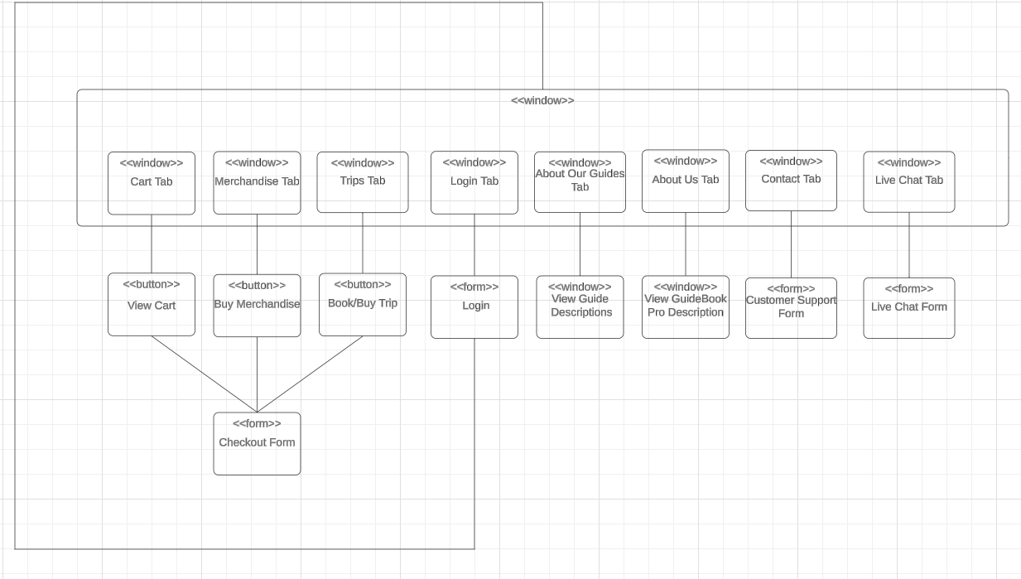
3.2 User Interface Narrative
The user Interface Diagram is a navigation system for the client-based view of our website. It shows how the website interacts and is interacted with.
3.3 User Interface Screen Layouts
3.4 User Interface Prototypes
Use Case 1: 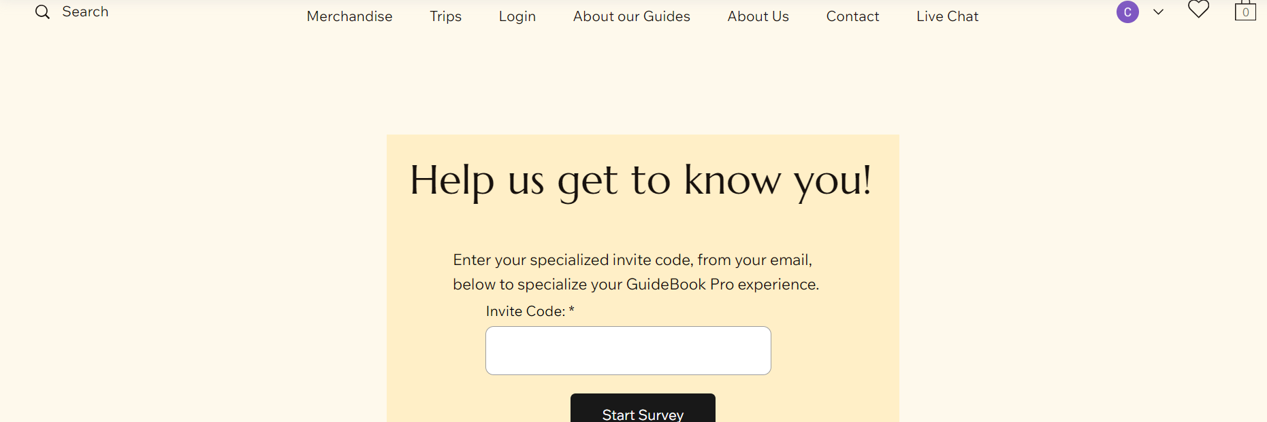
Use Case 2: 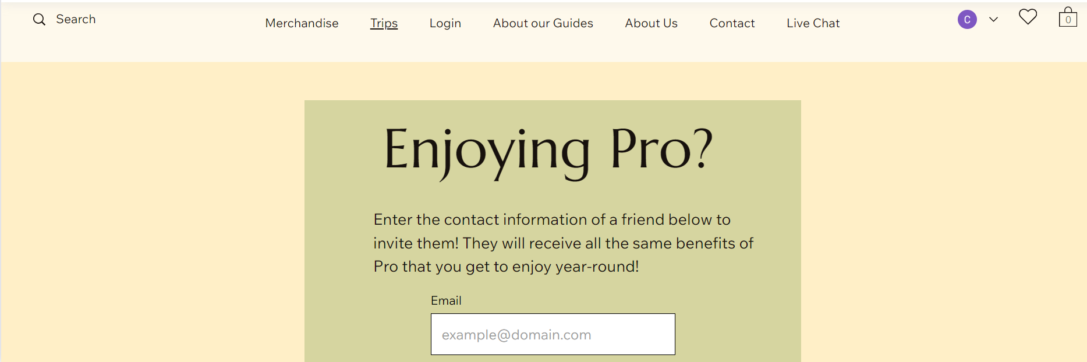
Use Case 3: 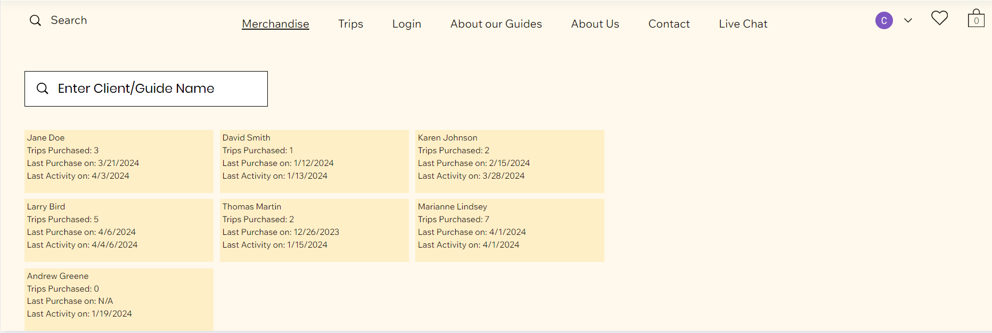
Use Case 4: 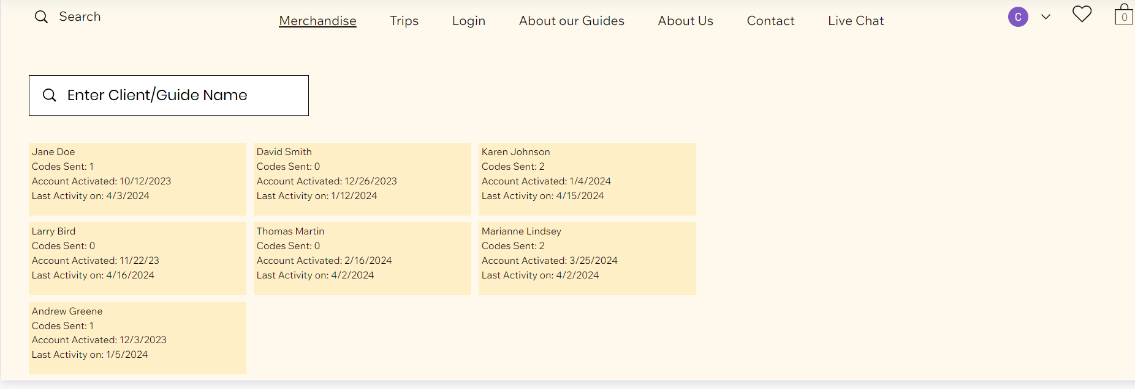
Use Case 5: 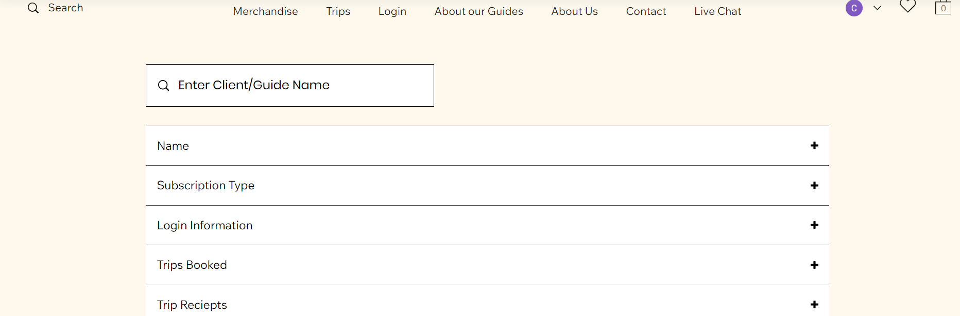
Use Case 6: 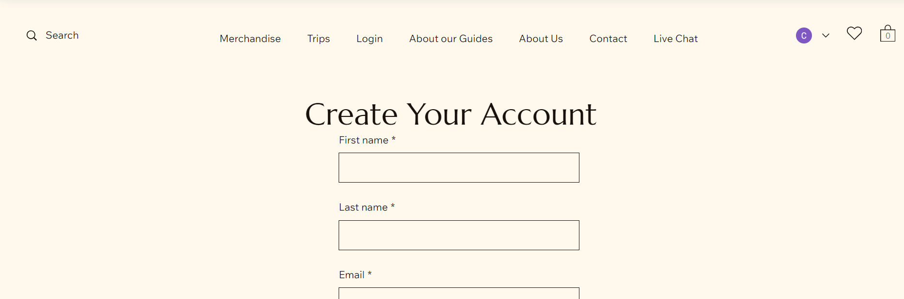
Use Case 7:
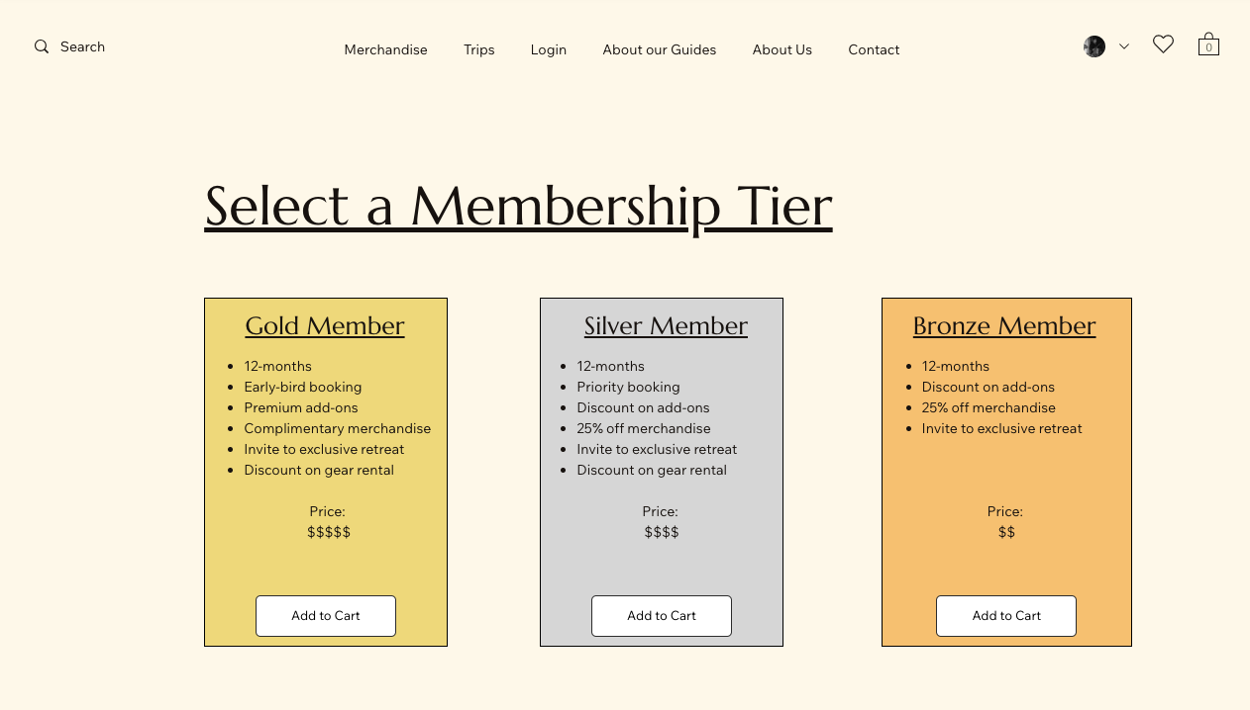
Use Case 8:
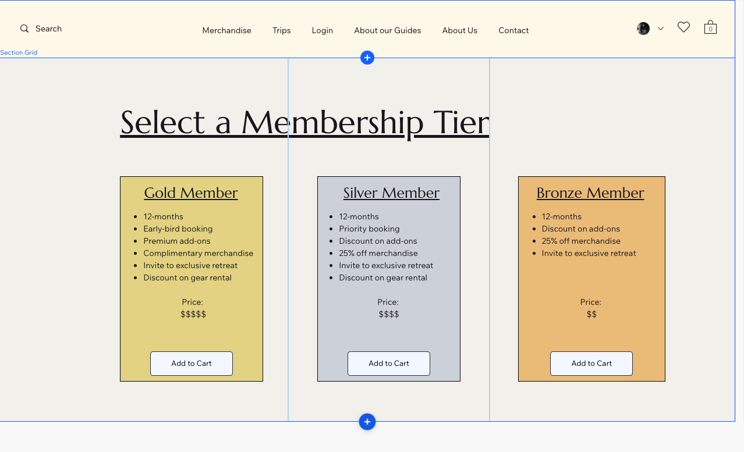
Use Case 9:
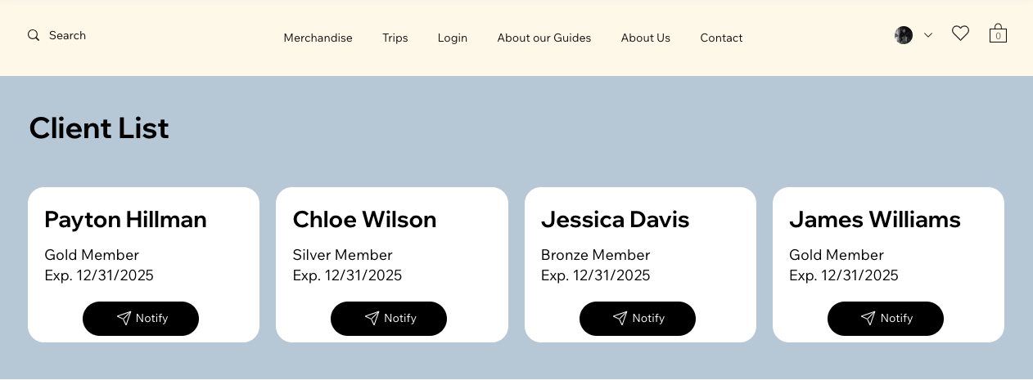

Use Case 10:
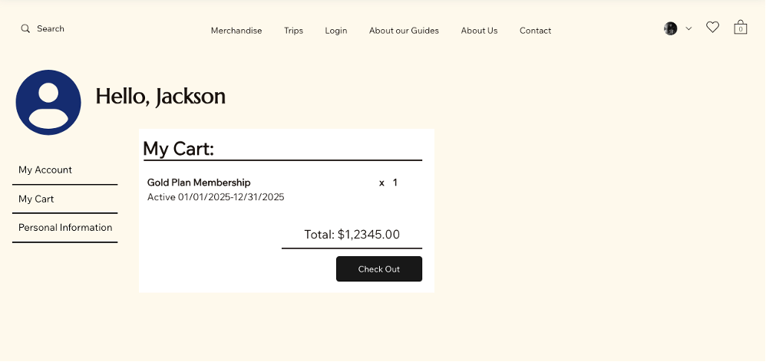

Use Case 11:
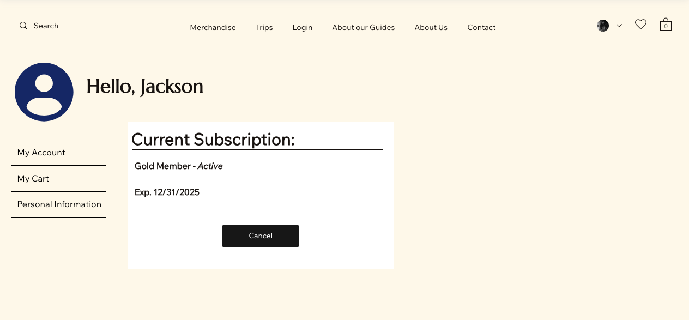

Use Case 12:
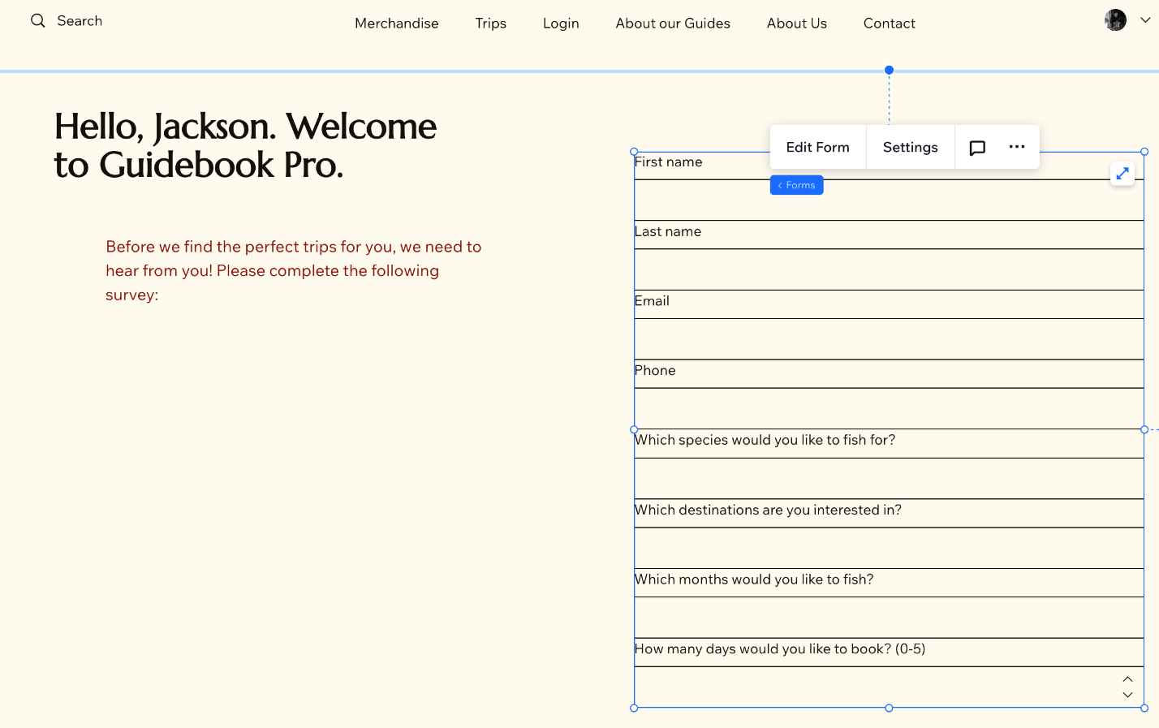

Use Case 13:
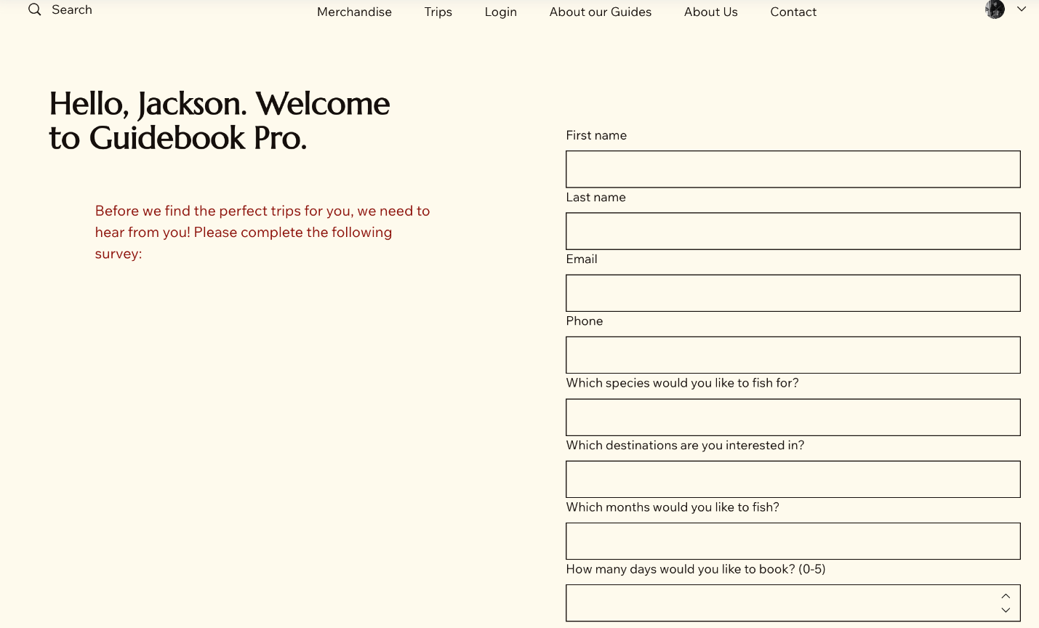
Use Case 14:
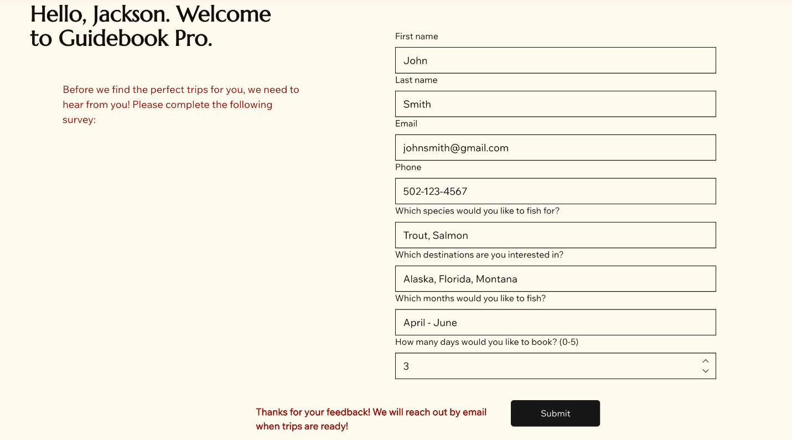
Use Case 15:
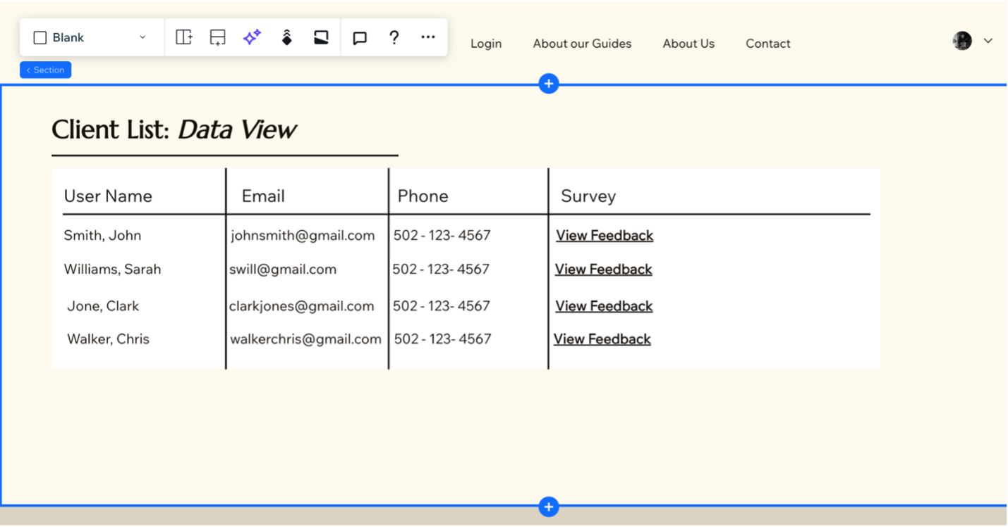
Use Case 16:
Use Case 17:
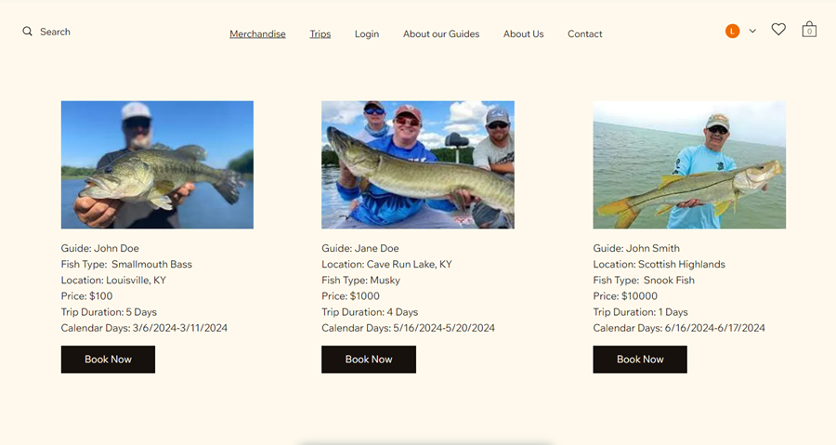
Use Case 18: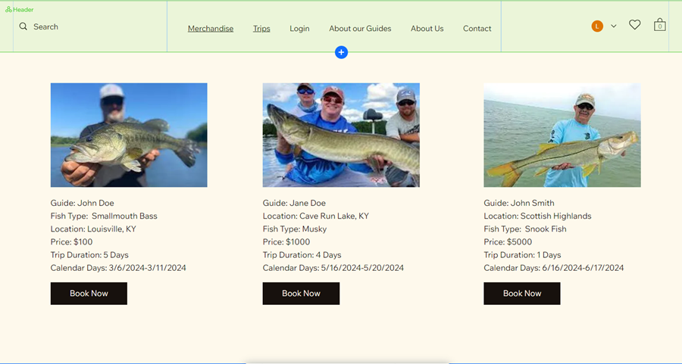
Use Case 19:

Use Case 20:
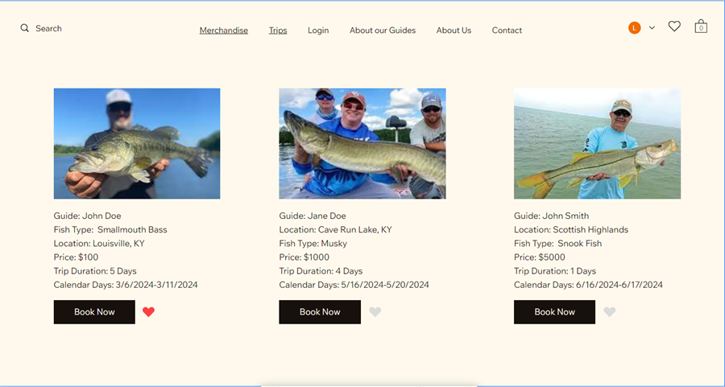
Use Case 21: 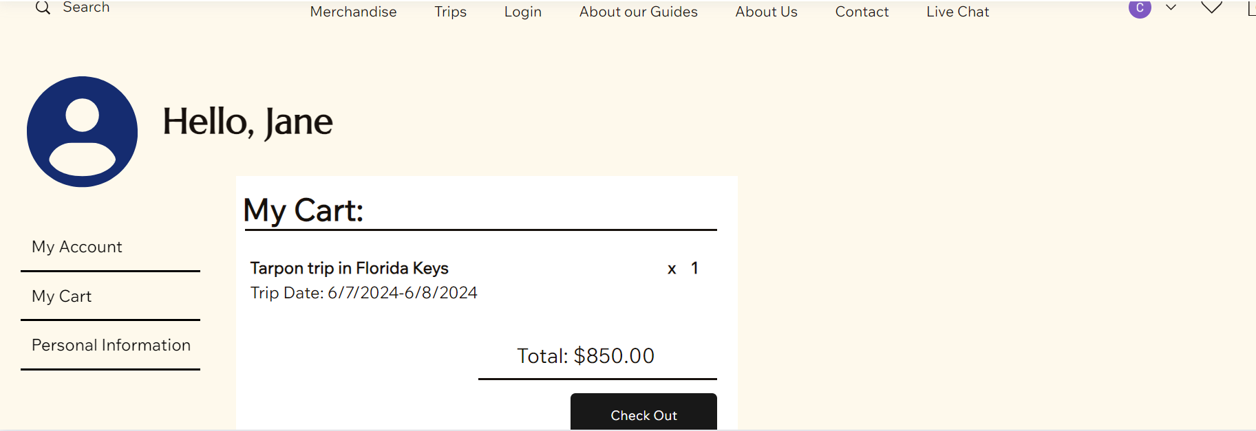
Use Cases 22-23: 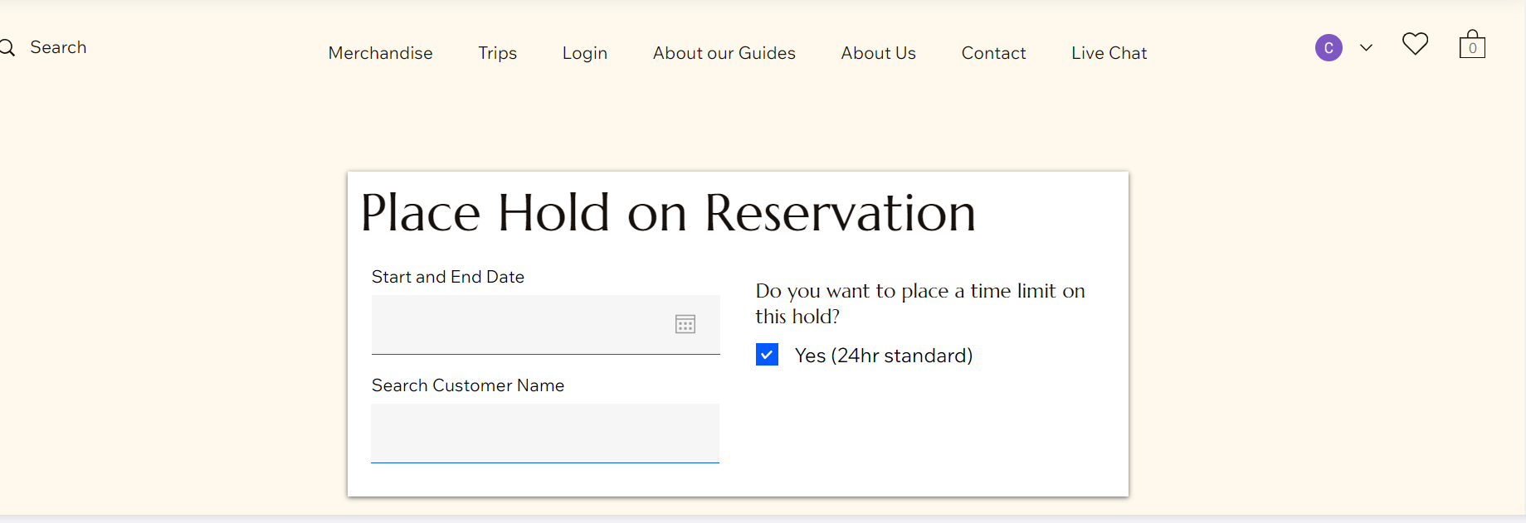
Use Case 24:
Use Case 25:
Use Case 26:
Use Case 27:
Use Case 28:
Use Case 29:
Use Case 30:
Use Case 31:

Use Case 32:
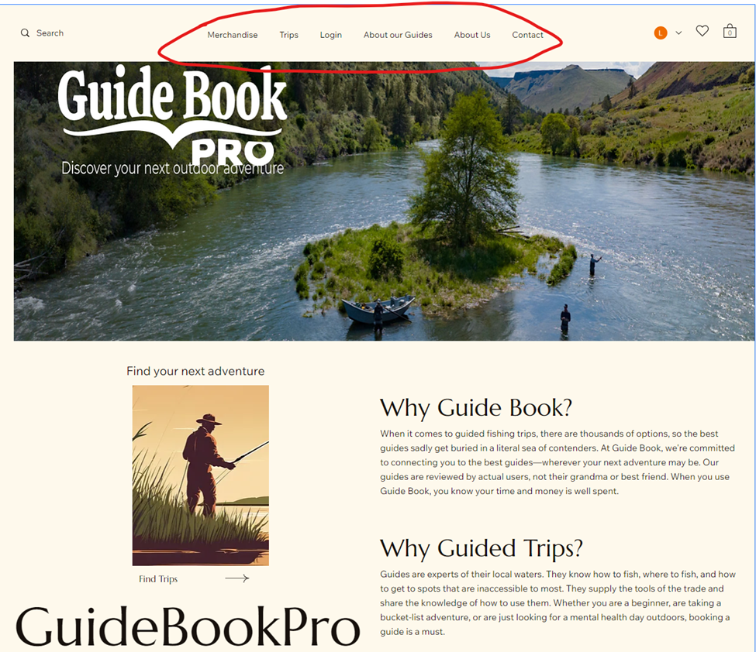

Use Case 33-37:
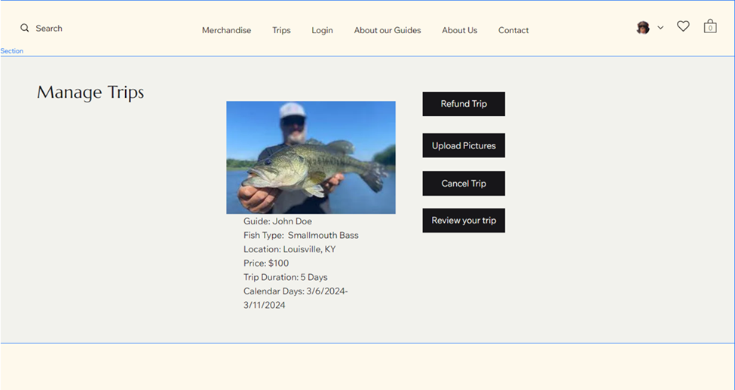
Use Case 38:
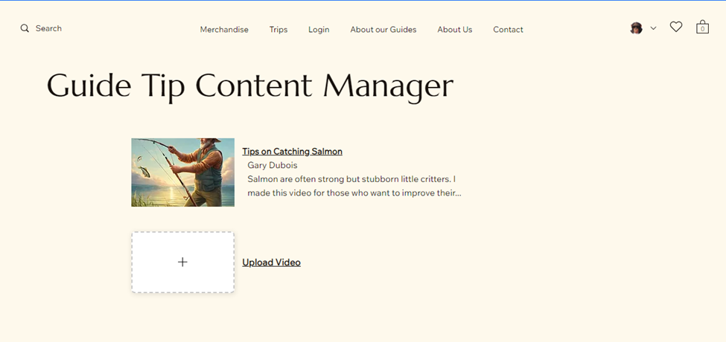
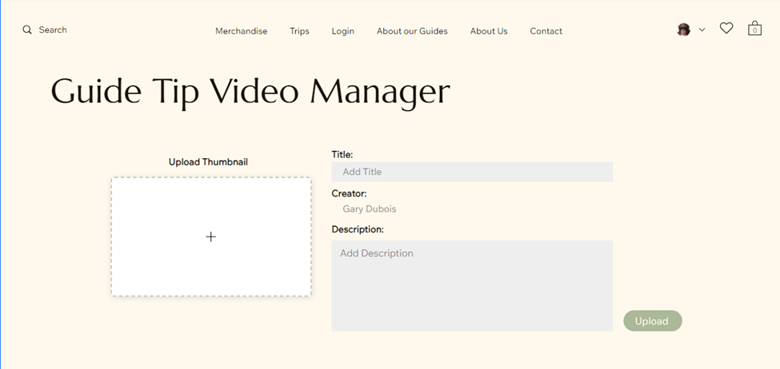
Use Case 39:
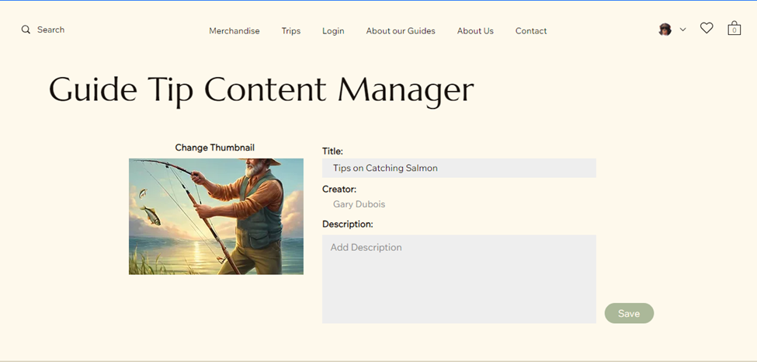
Use Case 40:
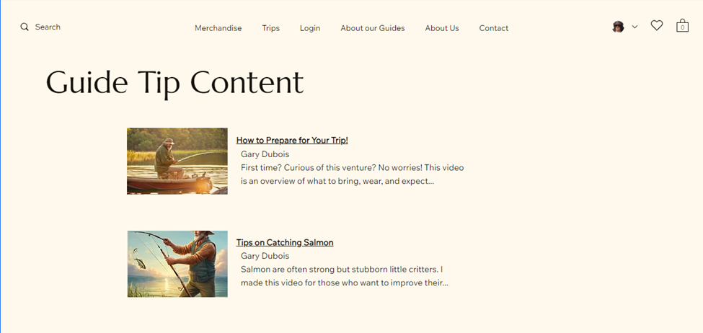
Use Case 41: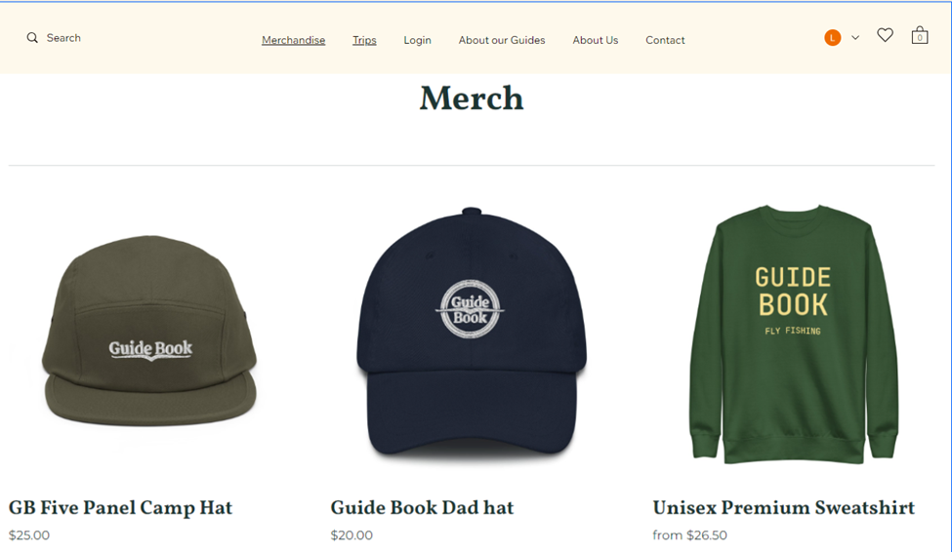
Use Case 42:
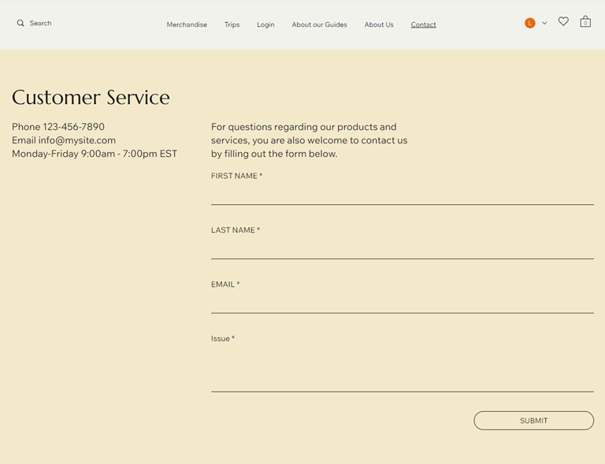
Use Case 43:

4. Gantt Chart

4.1 Gantt Chart Spreadsheet
Excel Sheet Link
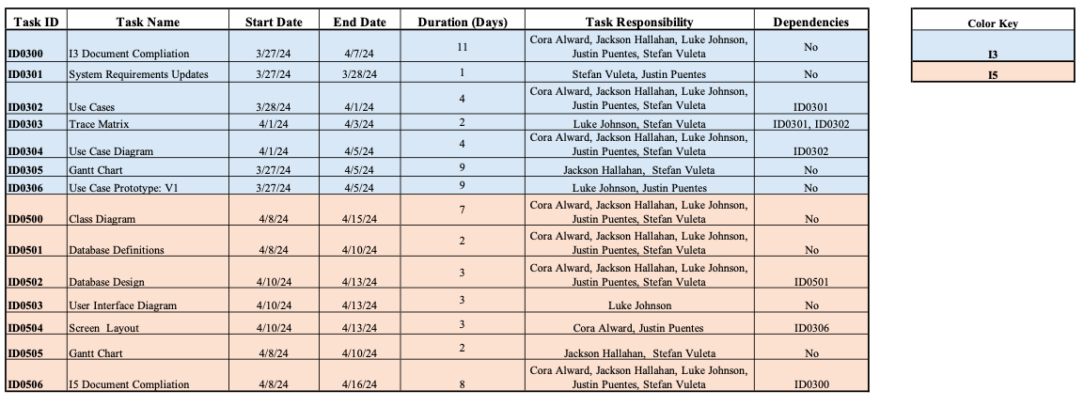

4.2 Gantt Chart

